**CODING CONTEST 1**

**QUESTION 1:**

package Question1;

import org.openqa.selenium.By;

import org.openqa.selenium.WebDriver;

import org.openqa.selenium.chrome.ChromeDriver;

import org.openqa.selenium.chrome.ChromeOptions;

import io.github.bonigarcia.wdm.WebDriverManager;

public class Question1 {

public static void main(String[] args) {

ChromeOptions co=new ChromeOptions();

co.addArguments ("--remote-allow-origins=*");

WebDriverManager.chromedriver().setup ();

WebDriver driver=new ChromeDriver();

driver.get ("https://www.saucedemo.com/");

driver.findElement(By.xpath("//*[@id=\"user-name\"]")).sendKeys("standard_user");

driver.findElement(By.xpath("//*[@id=\"password\"]")).sendKeys("secret_sauce");

driver.findElement(By.xpath("//*[@id=\"login-button\"]")).click();

driver.findElement(By.xpath("//*[@id=\"add-to-cart-sauce-labs-backpack\"]")).click();

String initial = driver.findElement(By.xpath("//*[@id=\"item_4_title_link\"]/div")).getText();

driver.findElement(By.xpath("//*[@id=\"shopping_cart_container\"]/a")).click();

String cart = driver.findElement(By.xpath("//*[@id=\"item_4_title_link\"]/div")).getText();

if(cart.equals(initial)) {

System.out.println("Successfully product added to the cart");

}

else {

System.out.println("oops");

}

String check_cart = driver.findElement(By.xpath("//*[@id=\"continue-shopping\"]")).getText();

System.out.println(check_cart);

if(check_cart.equals("Continue Shopping")) {

System.out.println("Hey ! cart is opened smoothly ");

}

else {

System.out.println("oops");

}

driver.findElement(By.xpath("//*[@id=\"checkout\"]")).click();

String checkout = driver.findElement(By.xpath("//*[@id=\"header_container\"]/div[2]/span")).getText();

if(checkout.equals("Checkout: Your Information")) {

System.out.println("Your information displayed");

}

else {

System.out.println("oops");

}

driver.findElement(By.xpath("//*[@id=\"first-name\"]")).sendKeys("KOKUL KANNA");

driver.findElement(By.xpath("//*[@id=\"last-name\"]")).sendKeys("S");

driver.findElement(By.xpath("//*[@id=\"postal-code\"]")).sendKeys("620021");

driver.findElement(By.xpath("//*[@id=\"continue\"]")).click();

String product_name = driver.findElement(By.xpath("//*[@id=\"item_4_title_link\"]/div")).getText();

String product_price = driver.findElement(By.xpath("//*[@id=\"item_4_title_link\"]/div")).getText();

if(product_name.equals(cart)) {

System.out.println("Entire product overview is displayed");

System.out.println("Product Name"+product_name);

System.out.println("Product price"+product_price);

}

else {

System.out.println(cart);

System.out.println(product_name);

}

String title = driver.getTitle();

if(title.equals("Swag Labs")) {

System.out.println("title matched");

}

else {

System.out.println("title mismatched");

}

if(driver.getCurrentUrl().equals("https://www.saucedemo.com/checkout-step-two.html")) {

System.out.println("url matched");

}

else {

System.out.println("url mismatched");

}

}

}

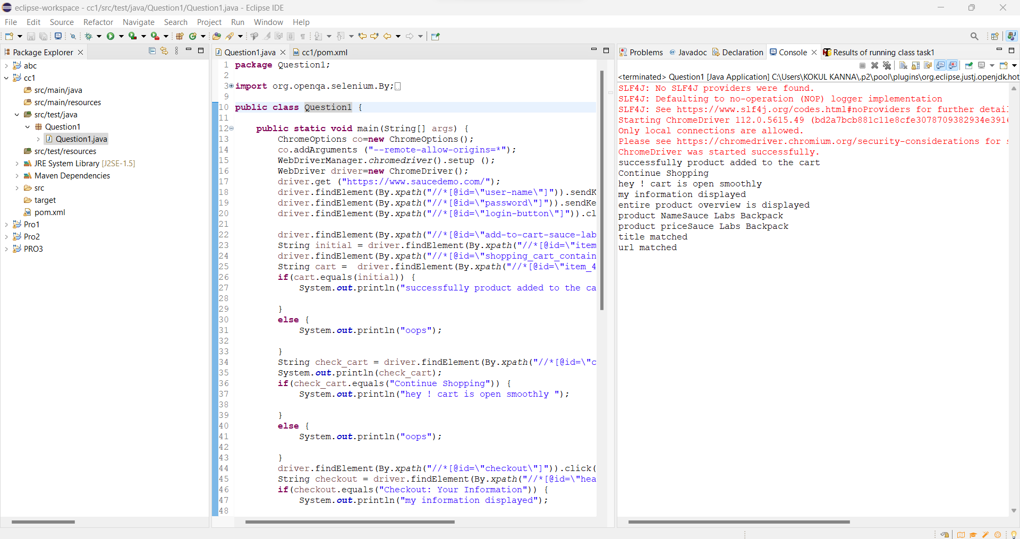

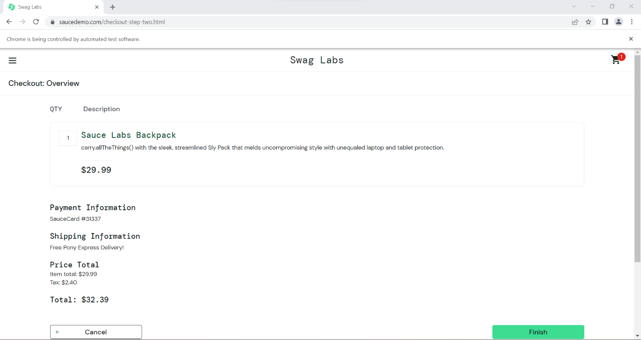

**QUESTION 2:**

**package** Question2;

**import** org.openqa.selenium.By;

**import** org.openqa.selenium.WebDriver;

**import** org.openqa.selenium.WebElement;

**import** org.openqa.selenium.chrome.ChromeDriver;

**import** org.openqa.selenium.chrome.ChromeOptions;

**import** io.github.bonigarcia.wdm.WebDriverManager;

**public** **class** Question2 {

**public** **static** **void** main(String[] args) **throws** InterruptedException {

// **TODO** Auto-generated method stub

ChromeOptions co=**new** ChromeOptions();

co.addArguments ("--remote-allow-origins=*");

WebDriverManager.*chromedriver*().setup ();

WebDriver driver=**new** ChromeDriver(co);

driver.get ("https://www.saucedemo.com/");

driver.manage().window().maximize() ;

WebElement txtBoxl=driver.findElement(By.*xpath*("//*[@id=\"user-name\"]"));

txtBoxl.sendKeys("standard_user");

WebElement txtBox2=driver.findElement(By.*xpath*("//*[@id=\"password\"]"));

txtBox2.sendKeys("secret_sauce");

driver.findElement(By.*xpath*("//*[@id=\"login-button\"]")).click();

String txt1=driver.findElement(By.*xpath*("//*[@id=\"item_4_title_link\"]/div")).getText();

System.***out***.println(txt1);

driver.findElement(By.*xpath*("//*[@id=\"header_container\"]/div[2]/div/span/select")).click();

driver.findElement(By.*xpath*("//*[@id=\"header_container\"]/div[2]/div/span/select/option[2]")).click();

String txt2=driver.findElement(By.*xpath*("//*[@id=\"item_3_title_link\"]/div")).getText();

System.***out***.println(txt2);

System.***out***.println("filter (A-Z and Z-A) used smoothly");

driver.findElement(By.*xpath*("//*[@id=\"header_container\"]/div[2]/div/span/select")).click();

driver.findElement(By.*xpath*("//*[@id=\"header_container\"]/div[2]/div/span/select/option[3]")).click();

String txt3=driver.findElement(By.*xpath*("//*[@id=\"inventory_container\"]/div/div[1]/div[2]/div[2]/div")).getText();

System.***out***.println(txt3);

driver.findElement(By.*xpath*("//*[@id=\"header_container\"]/div[2]/div/span/select")).click();

driver.findElement(By.*xpath*("//*[@id=\"header_container\"]/div[2]/div/span/select/option[4]")).click();

String txt4=driver.findElement(By.*xpath*("//*[@id=\"inventory_container\"]/div/div[1]/div[2]/div[2]/div")).getText();

System.***out***.println(txt4);

System.***out***.println("filter (low price- high price and high price - low price )used smoothly");

Thread.*sleep*(5000);

}

}

